# ER Diagram and Relational Schema for Train Ticket Reservation system

**Our Team,**

1. **AS2021403 - D.P.G.A.H. Kulathilaka**
2. **AS2021367 - T.G.D.S. Chathuranga**
3. **AS2021573 - M.A.S.E.R. Wijerathna**
4. **AS2021457 - R.M.D.D. Malinda**
5. **AS2021517 - P.T.S. Karunarathna**
6. **AS2021535 - H.R.S.U. Ranasinghe**
7. **AS2021637 - M.A. Sathsarani**
8. **AS2021359 - G.P.G. Pasqual**

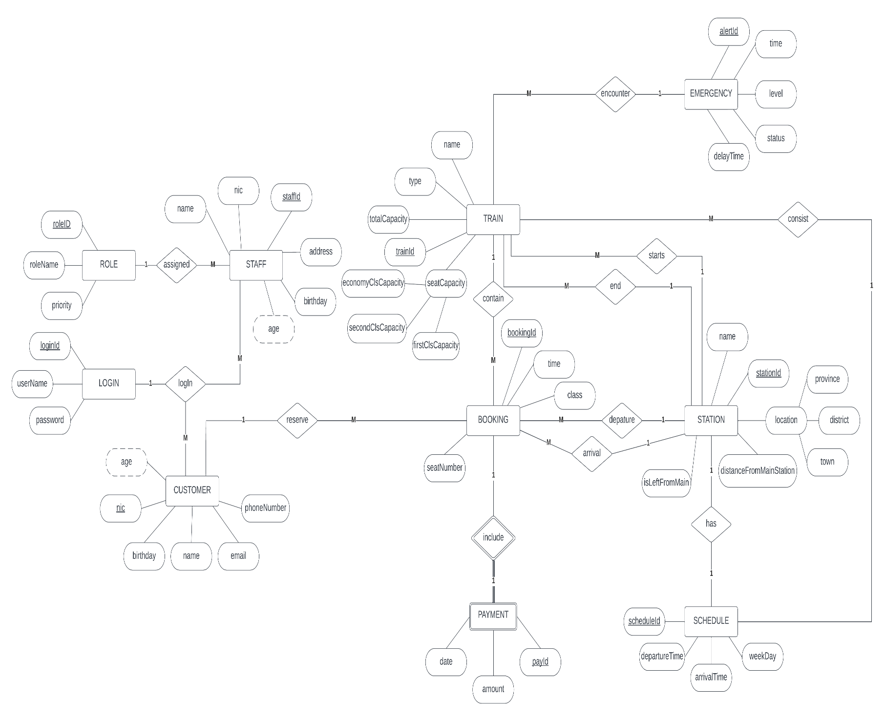

## Entity Relationship Diagram

Assumptions-

1. Customer needs to log, in order to make a reservation.
2. All rail tracks are interconnected.
3. In order to calculate the fare we used a variable length in KM as “distanceFromMain”.
4. In the database Petta station taken as the main station.
5. To identify whether the station is left or right from the main station a Boolean value was used in STATION entity as “isLeftFromMain”.

## Relational Schema